**EXPERIMENT – 8, 9**

1. Write a Query to display the Information present in the Passenger and cancellation tables. Hint: Use UNION Operator.

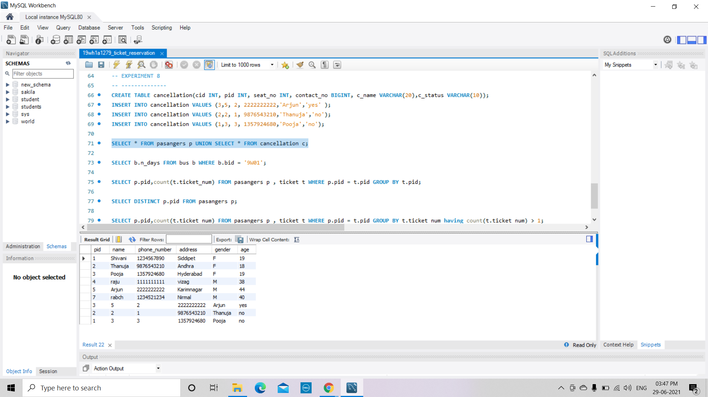

2. Display the number of days in a week on which the 9W01 bus is available.

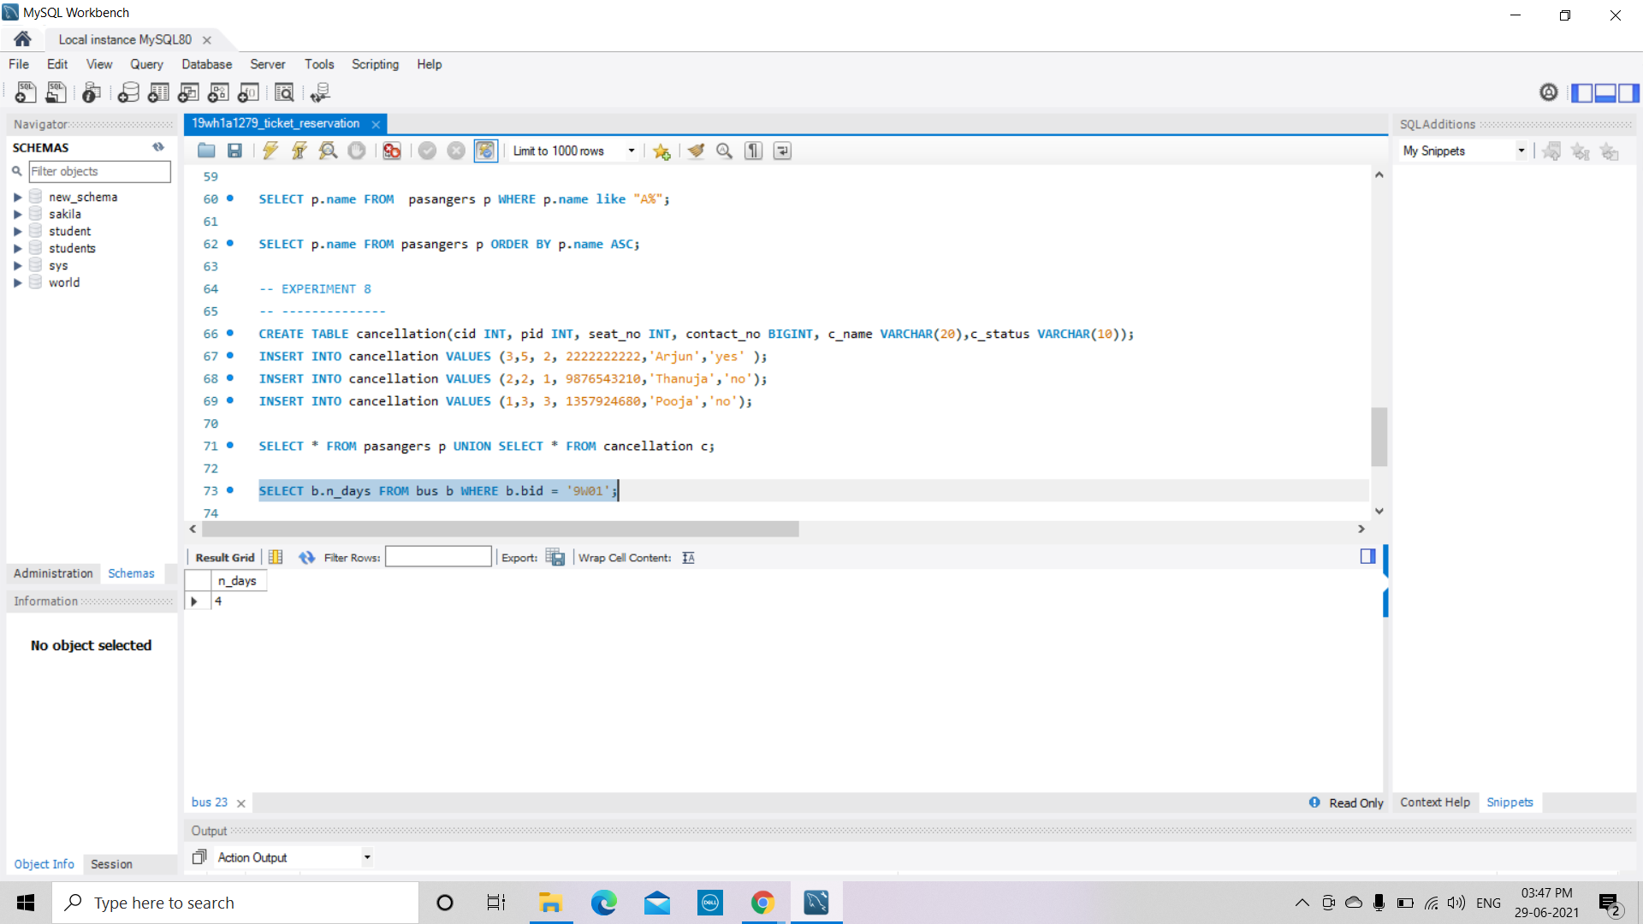

3. Find number of tickets booked for each PNR_no using GROUP BY CLAUSE.

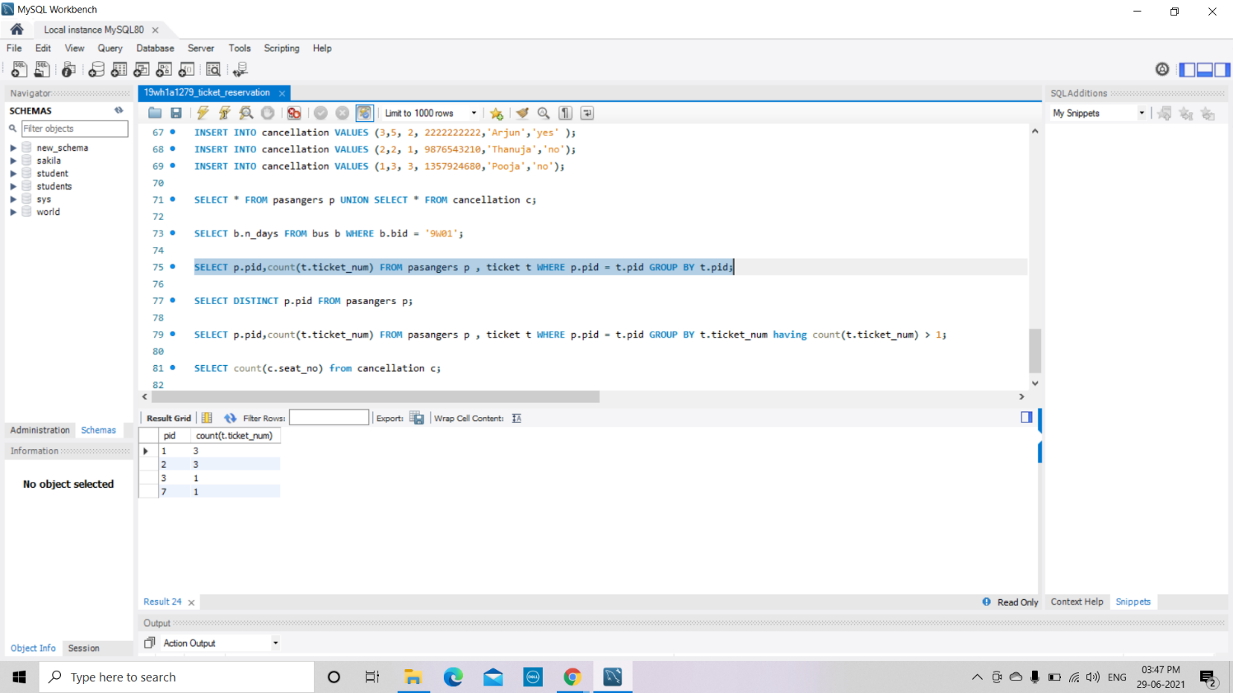

4. Find the distinct PNR numbers that are present

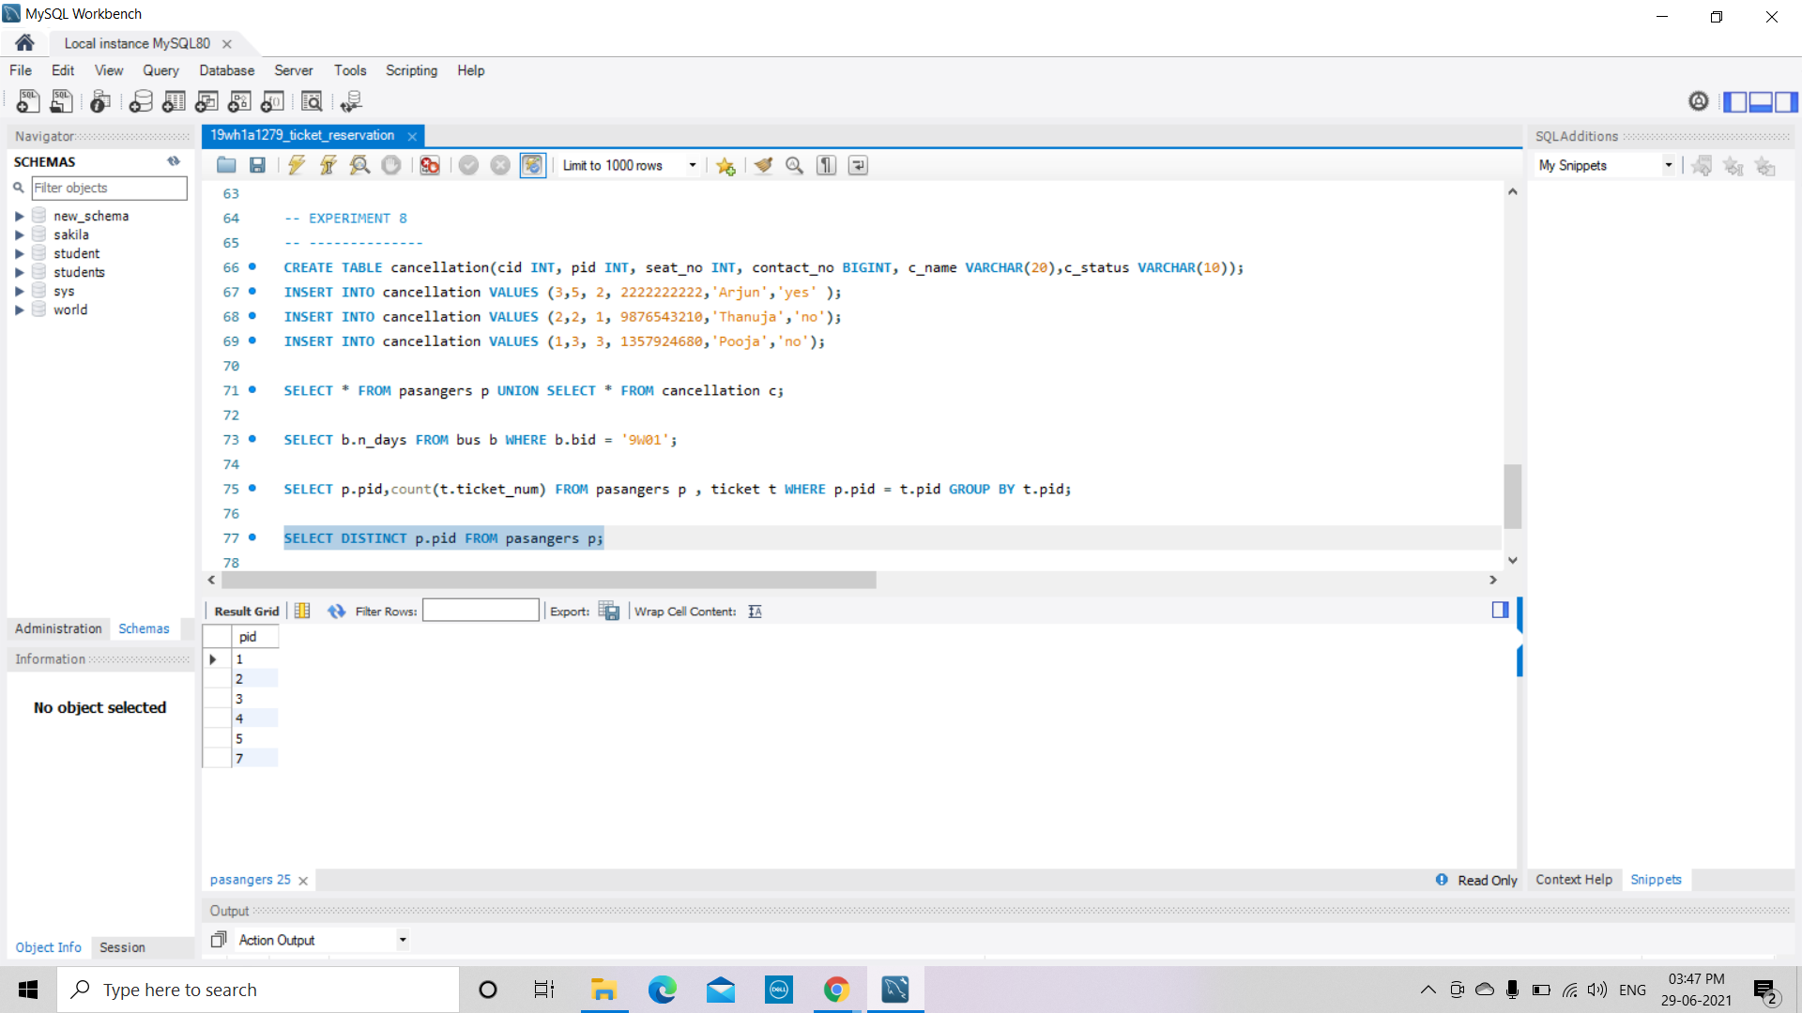

5. Find the number of tickets booked by a passenger where the number of seats is greater than 1

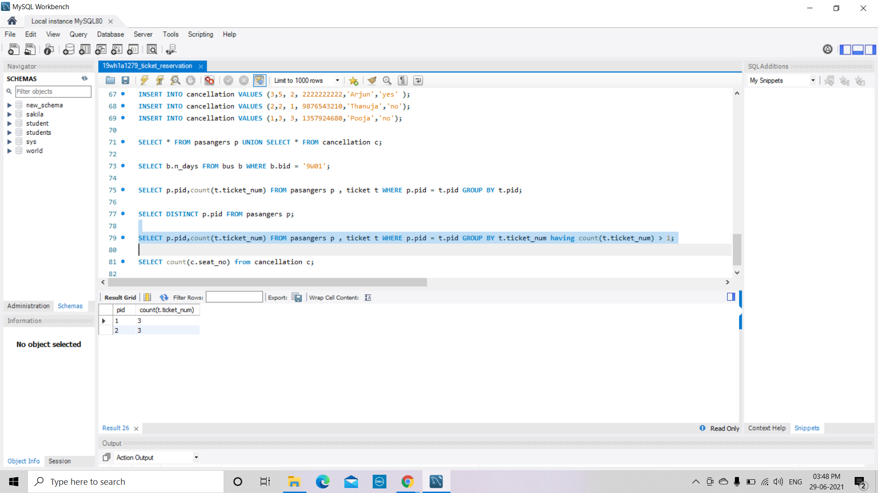

6. Find the total number of cancelled seats.

